PCR Genotyping of Sox9 flox
(Applied to Sox9^{flox/flox} etc.)

PCR primers
Sox9flox-F AGACTCTGGGCAAGCTCTGG
Sox9flox-R GTCATATTCACGCCCCCATT
Product Sizes wt: 250bp
Mutant: 300bp
Note: in the Cre-floxed animals, the entire exon2 and exon3 are excised.
DNA prep: Use the proteinase K protocol for genomic DNA preparation! The Alkaline buffer protocol does not work for this specific gene.
Note: Use 2% agarose gel to separate the mutant and wt band. Run a longer gel.
PCR Reaction Mix
10 µl Green Master Mix (Promega M7122)
7 µl di-H2O
1 µl Forward/Reverse primer mix *
2 µl gDNA
20 µl
*to make primer mix, add 10 µl of forward primer (100 µM stock) and 10 µl of reversed primer (100 µM stock) to 80 µl of di-H2O.

PCR Program (55C)
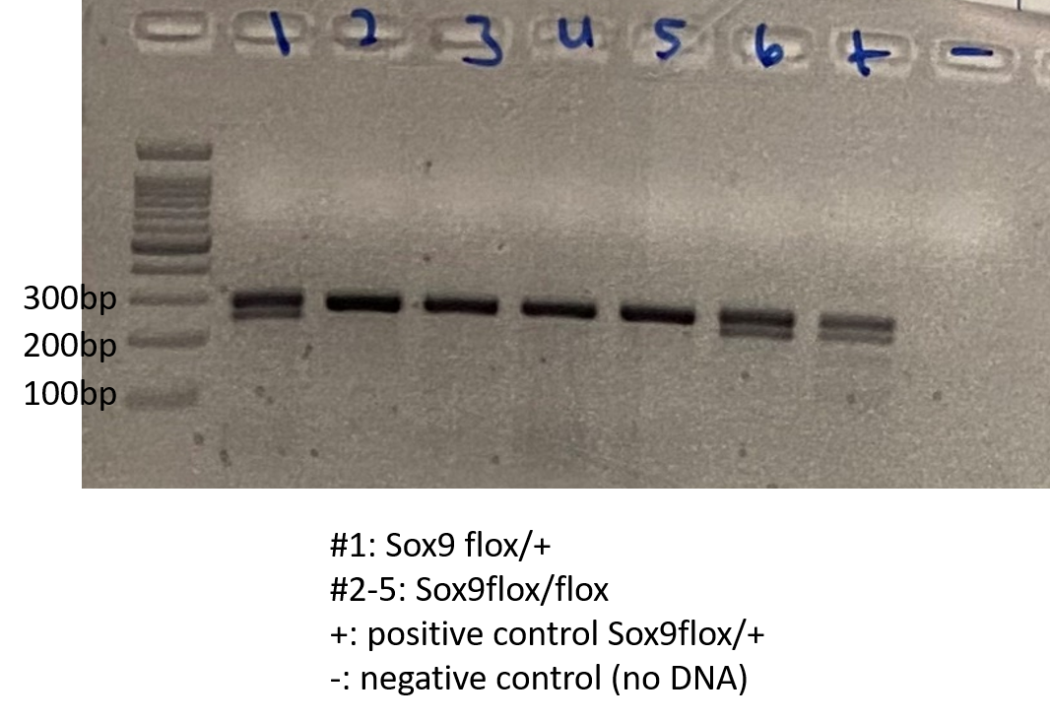
- 94 °C 3min
- 94 °C 30sec
- 55 °C 30sec
- 72 °C 1min
- Go to 2, repeat 34x
- 72 °C 5min
- Keep at 12 °C

The “Genotyping” program also works.

