PCR Genotyping of Sox9 Asp272del NEW PROTOCOL

PCR primers
Sox9 del wt only-F ATCGACTTCCGCGACG
Sox9 del GT-R TGGCAAGTATTGGTCAAACTCA

Sox9 del mutant only-F CCATCGACTTCCGCGTGG
Sox9 del GT-R TGGCAAGTATTGGTCAAACTCA

Note: Reverse primers are the same. It is also the same reversed primer used for the OLD PROTOCOL.

Product Sizes Mutant band: 156 bp; Wild type band: 156 bp
Need to run two separate PCRs for wt and mutant primers. Wild type animals will only show a 156bp band in wt reaction. Heterozygous will show two 156bp bands in both reactions. Mutant animals will only show a 156bp band in mutant reaction.
PCR Reaction Mix
10 µl Green Master Mix (Promega M7122)
7 µl di-H2O
1 µl Forward/Reverse primer mix *
2 µl gDNA
20 µl
*to make primer mix, add 10 µl of forward primer (100 µM stock) and 10 µl of reversed primer (100 µM stock) to 80 µl of di-H2O.

PCR Program (SOX960D)
- 95 °C 3min
- 95 °C 15sec
- 60 °C 15sec
- 72 °C 1min
- Go to 2, repeat 34x
- 72 °C 5min
- Keep at 12 °C

PCR Genotyping of Sox9 Asp272del OLD PROTOCOL

PCR primers
Sox9 del GT-F GTCTTTCTCTTTTATGGCCTGC
Sox9 del GT-R TGGCAAGTATTGGTCAAACTCA

Product Sizes Mutant band: 233 bp; Wild type band: 236 bp
Note: Use 4% MetaPhor high resolution gel to separate bands. Run a longer gel (>50min). 90min gives better results.
PCR Reaction Mix
10 µl Green Master Mix (Promega M7122)
7 µl di-H2O
1 µl Forward/Reverse primer mix *
2 µl gDNA
20 µl
*to make primer mix, add 10 µl of forward primer (100 µM stock) and 10 µl of reversed primer (100 µM stock) to 80 µl of di-H2O.

PCR Program (55C)
- 94 °C 3min
- 94 °C 30sec
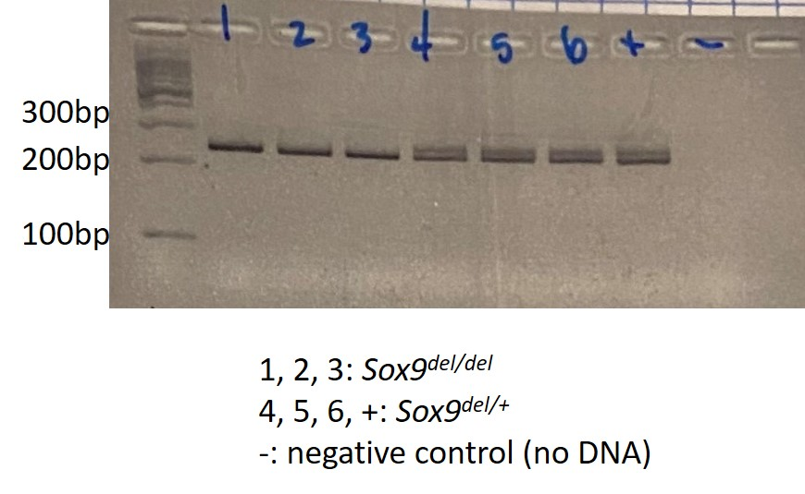
- 55 °C 30sec
- 72 °C 1min
- Go to 2, repeat 34x
- 72 °C 5min
- Keep at 12 °C
(Note: heterozygous Sox9^{del/+} will show two bands. Wild type (Sox9^{+/+}) and Sox9^{del/del} will show only one band. This protocol cannot distinguish wild type and Sox9^{del/del}. Sequencing is required!!)

