PCR Genotyping of Cre
(Applied to all the regular Cre lines)

PCR primers (5’-3’)
Cre2022-F GCAGAACCTGAAGATGTTCGC
Cre2022-R ACACCAGAGACGGAAATCCATC

Product Sizes 494 bp
Gel type 1% Agarose 10-20min

PCR Reaction Mix
10 µl Green Master Mix (Promega M7122)
7 µl di-H2O
1 µl Forward/Reverse primer mix *
2 µl gDNA
20 µl
*to make primer mix, add 10 µl of forward primer (100 µM stock) and 10 µl of reversed primer (100 µM stock) to 80 µl of di-H2O.

PCR Program (Genotyping)
- 94 °C 2min
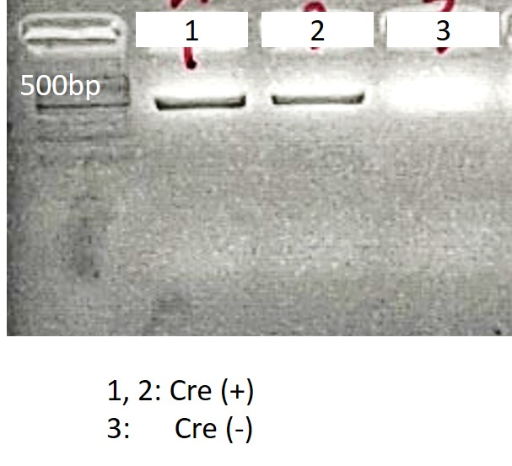
- 94 °C 15sec
- 63 °C 15sec
-0.5°C/cycle
- 72 °C 30sec
- Go to 2, repeat 10x
- 94 °C 15sec
- 60 °C 15sec
- 72 °C 30sec
- Go to 6, repeat 28x
- Keep at 12 °C
Total program takes 1h 15 min

